PJM SHORT CIRCUIT STUDY PROCEDURE

Version 1.3 - 02/11/2026

Edited By: Luke Eichten | Hussain Al-Digs

1.1 Files You Must Obtain (From PJM / Project Owner)
The following items are needed to perform the study. If you do not have PJM access, you must request the following from someone with a PJM laptop:
- OLR file – Most recent OneLiner model for the project
- OSF file – Short circuit options file (Specific to the project’s Queue Number)
  - ⚠️ Important: OSF files are project‑specific. Never reuse an OSF file from another queue, even if it is the same utility.
- QP Data
  - QP Printout
  - Single Line Diagram (SLD)

1.2 Internal Files You Need
- Calculation Spreadsheet Template

2. Determine Project Status (As‑Built vs. Necessary)
This affects file naming, assumptions, and documentation.

2.1 Check Project Status
- Go to PJM Serial Service
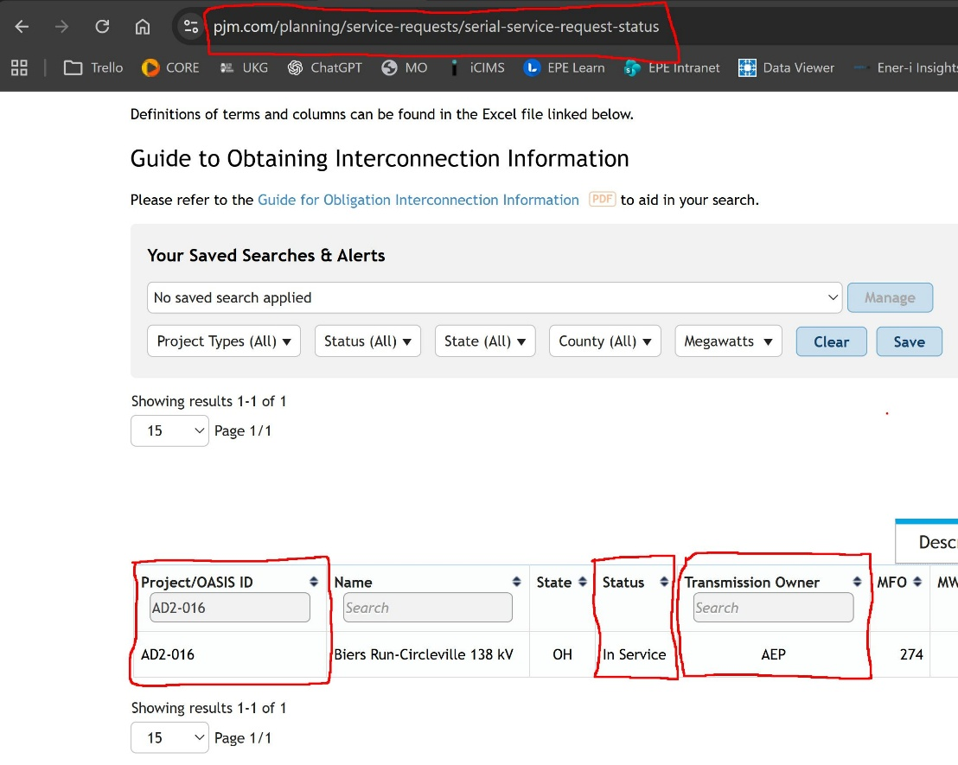
- Search by Project Queue Number
- Review project status:
  - In Service → As‑Built Project
  - Engineering / Procurement / Documentation → Necessary Project

2.2 Apply Correct Naming Convention
- Rename the calculation spreadsheet and OLR case according to:
  - Project number
  - As‑Built or Necessary designation
    - -i.e.: ABC-123_As-Built_Calculations.xlsx
    - ABC-123_As-Built_Without.OLR
This naming propagates through scripts and outputs—do this before running any cases.

3. Initial Data Review (Pre‑Study Gate)
Short circuit studies cannot proceed unless data review is approved. (Those with PJM access, verify this on QP)

Excel Spreadsheet Calculations and .chf change file
  - Using the QP data provided, fill in the calculations excel spreadsheet based on the specific project details provided to obtain the proper change file.
    - Make sure to be consistent with the naming of the buses based on the specific project configuration provided in the SLD/QP.
    - If deemed helpful, feel free to draw out the project configuration to make sure that you provide all the necessary buses in the spreadsheet as different projects have different configurations.
    - Whenever possible, input data provided on QP by directly copying and pasting the data rather than manually inputting the data to avoid any sort of human error associated with data entry and human error.
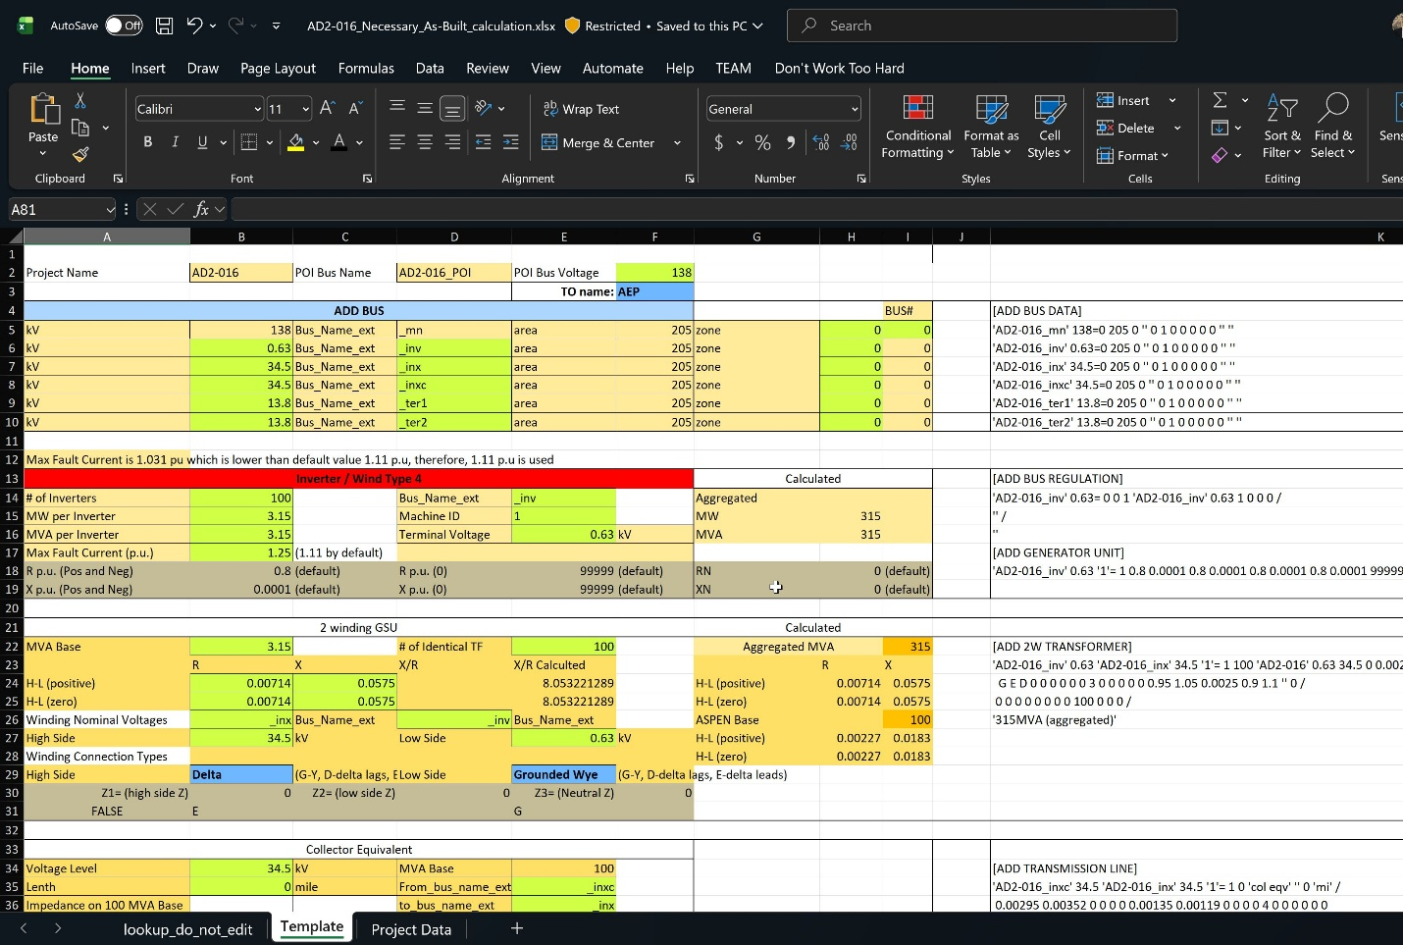
  - Once all data has been entered into the spreadsheet, column K associated with the .chf change file will have been updated. Therefore, create a text file and copy all of entries in column K into the text file and make sure to save it as ABC-123_As-Built.chf under “All File Types” and will later be applied to the “With” case for the study.
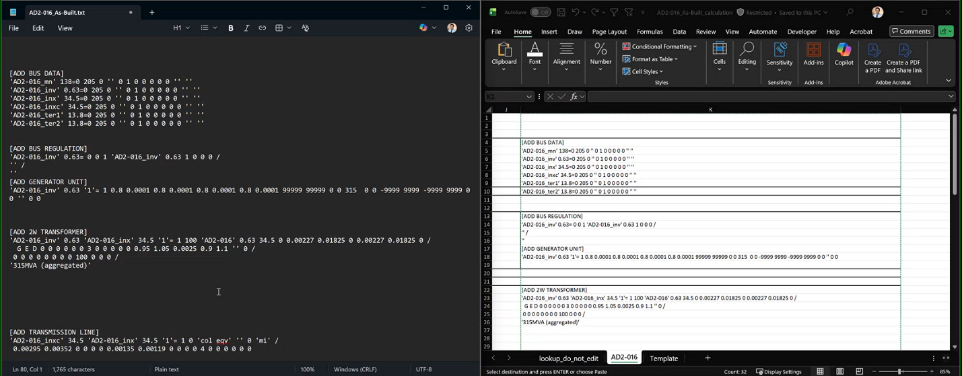
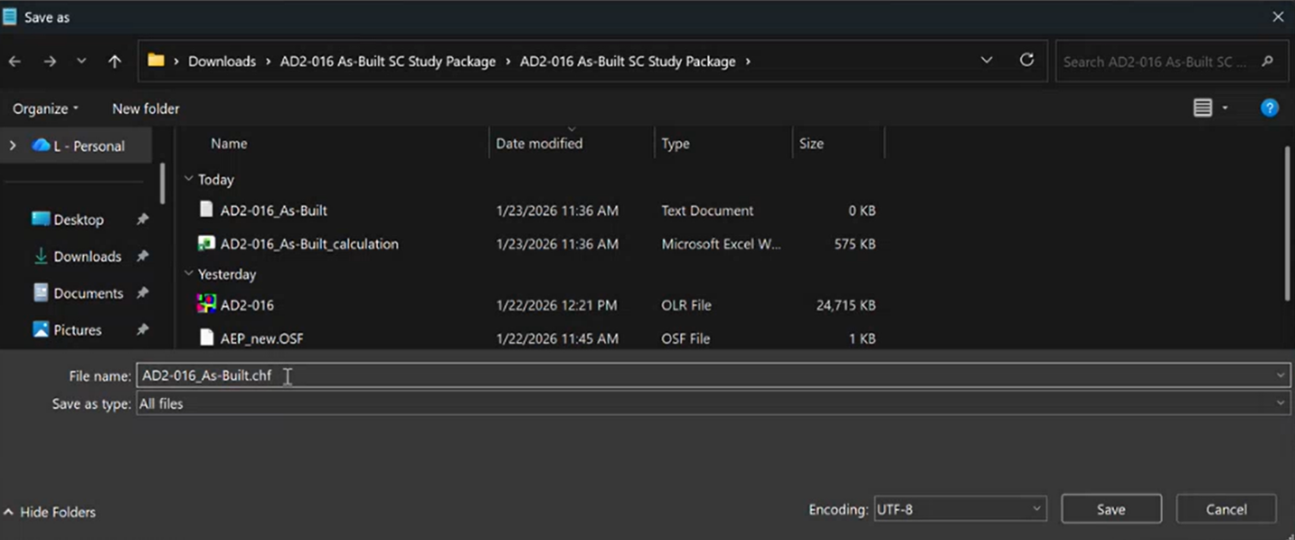

5. Open & Prepare the OLR Case

5.1 Open Base OLR File
- Launch ASPEN OneLiner
- Open the provided OLR file (from the most recent/previous study)
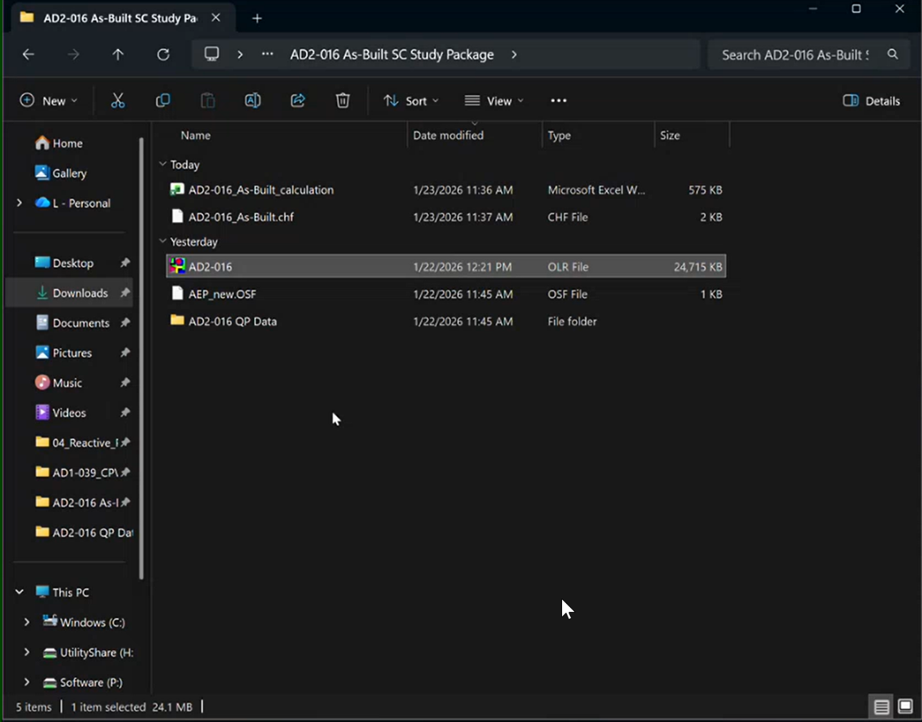

5.2 Establish Without-Project Case
- Hide any buses that are already present in the file by selecting the entire region and choosing the “Hide Buses Inside Region” option when right-clicking while selecting the region. Please make sure to hide them only and not delete them.
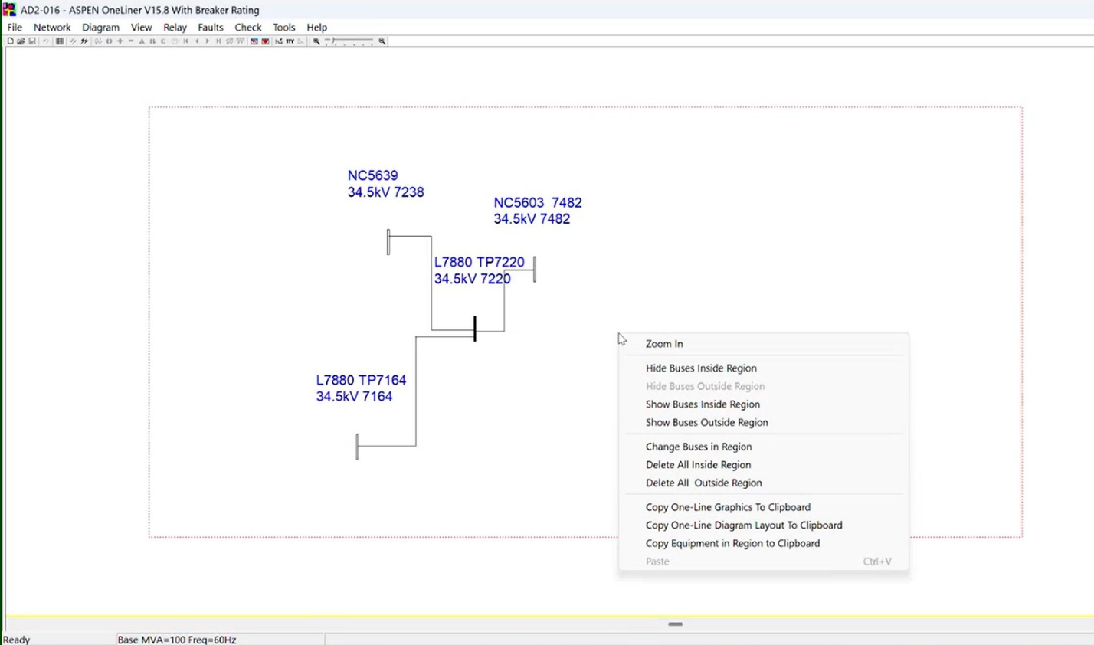
- Locate previous queue/project elements (Right click --> Place Bus --> Enter desired queue number
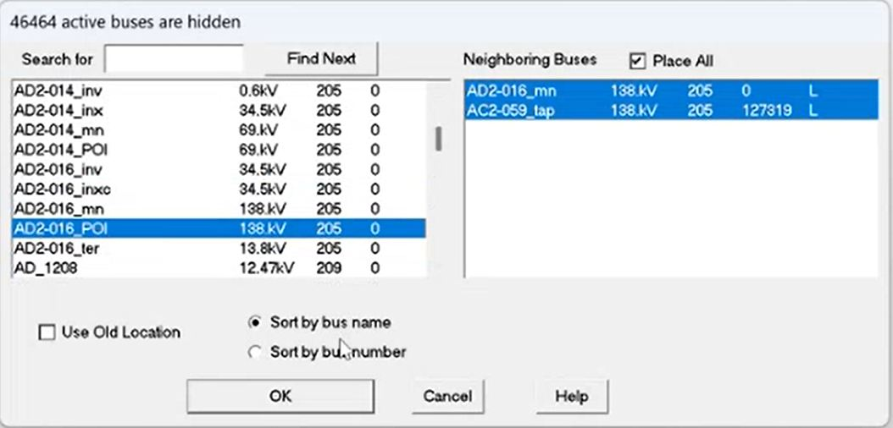
- Delete all project-specific elements except the POI (Delete inverters, GSUs, attachment, MPTs for ABC-123)
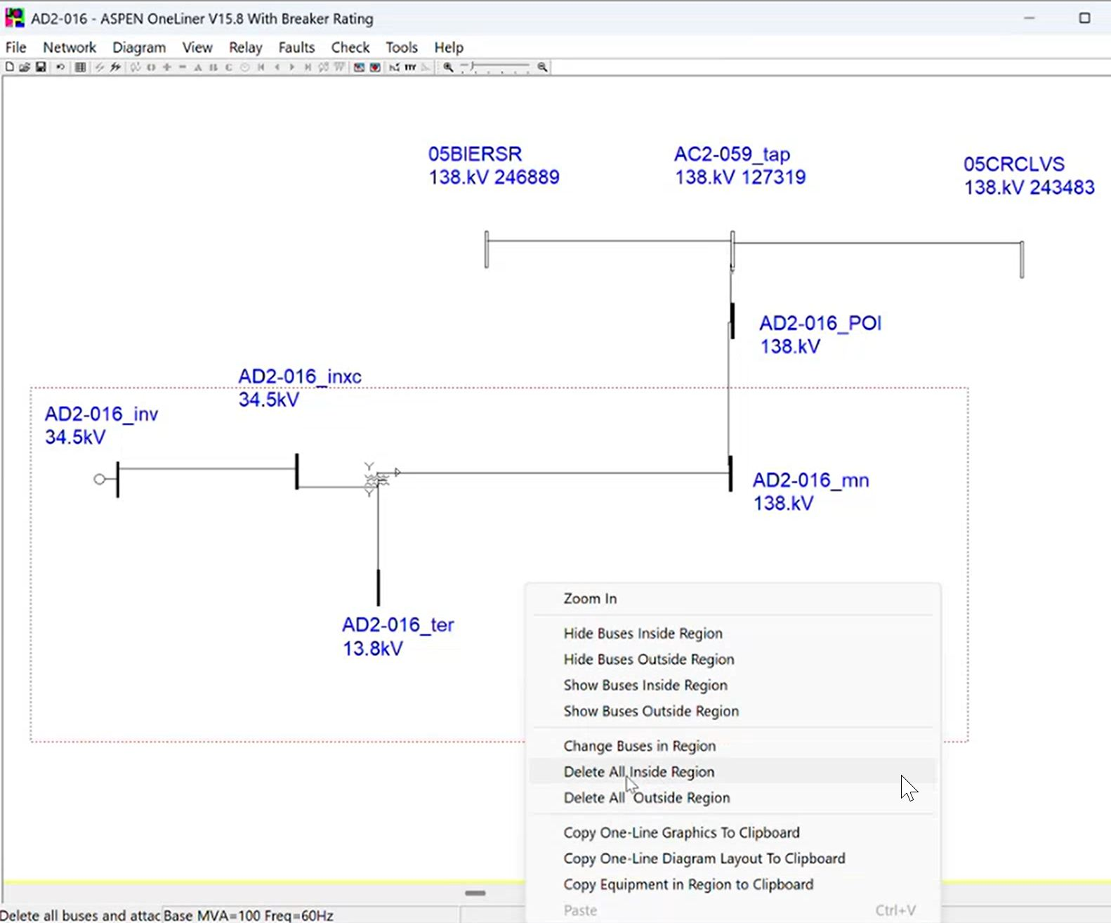
  - If a new POI is needed, create a bus and insert the POI bus associated with the project
- Expand it and add neighboring buses to make sure the model diagram is visible and clear, especially the region where change has occurred between the old and current model of the system.
- Adjust the parameters of the POI connections (only if the (miles/impedance) do not align with QP)
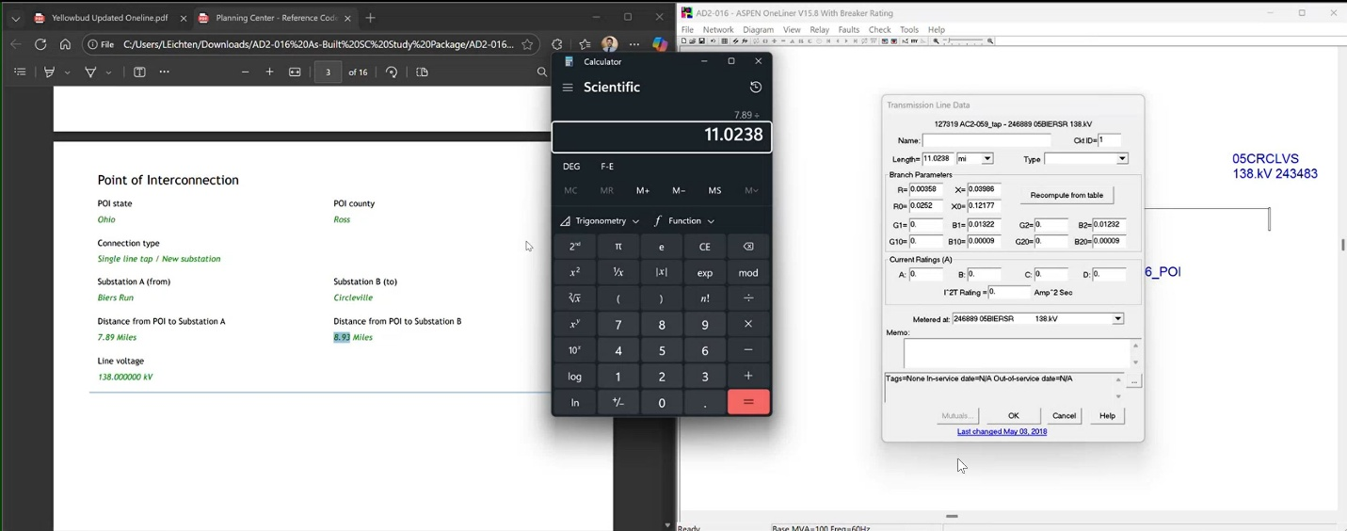
- Save WITHOUT case separately
- For the WITH case, you will take a copy of the without case and then apply the change file obtained earlier from the spreadsheet calculation.
- Open the copied WITH file and proceed to File → Case Builder → Then select the change file → Open → Rest OK.
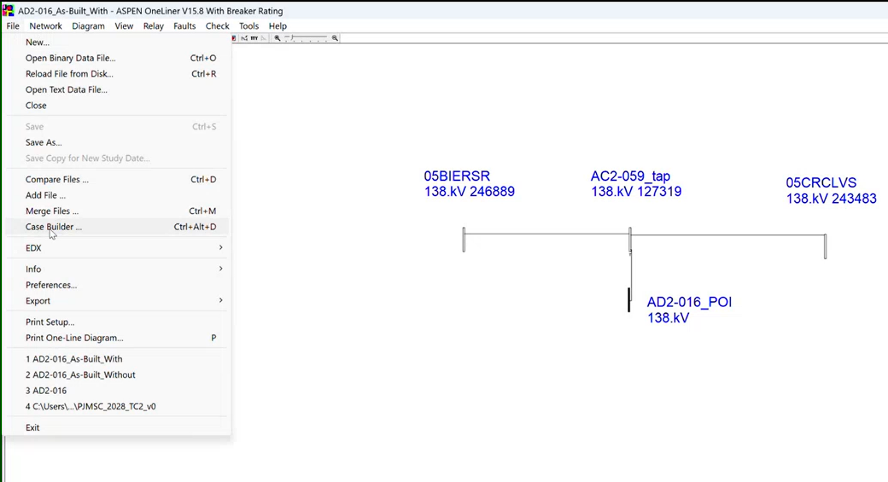

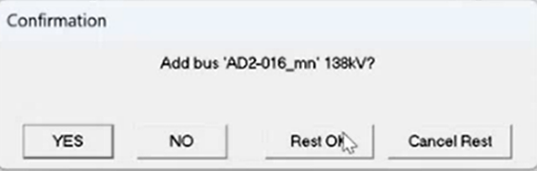
- If the change file was applied properly and without any issues, it will provide 0 errors/warnings. If there are errors or warnings, error debugging will need to be done before proceeding to the next step to ensure proper execution.
- Once the change file has been applied, expand the buses and make sure to organize them neatly in case you need to refer to them later. You would then proceed to set the generator reference angle as done during the WITHOUT case.
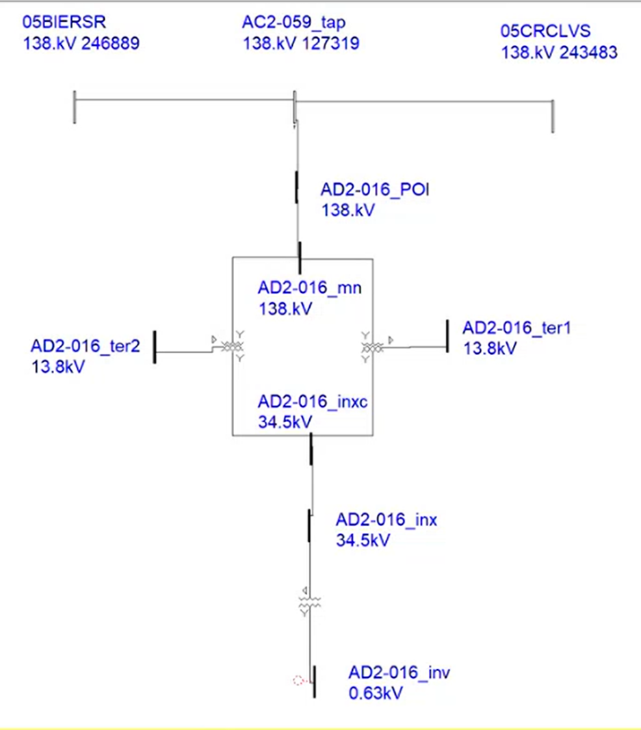

5.3 Set Generator Reference Angle
- Apply the generator reference angle (typically labeled as identifying number “30” or “200030”
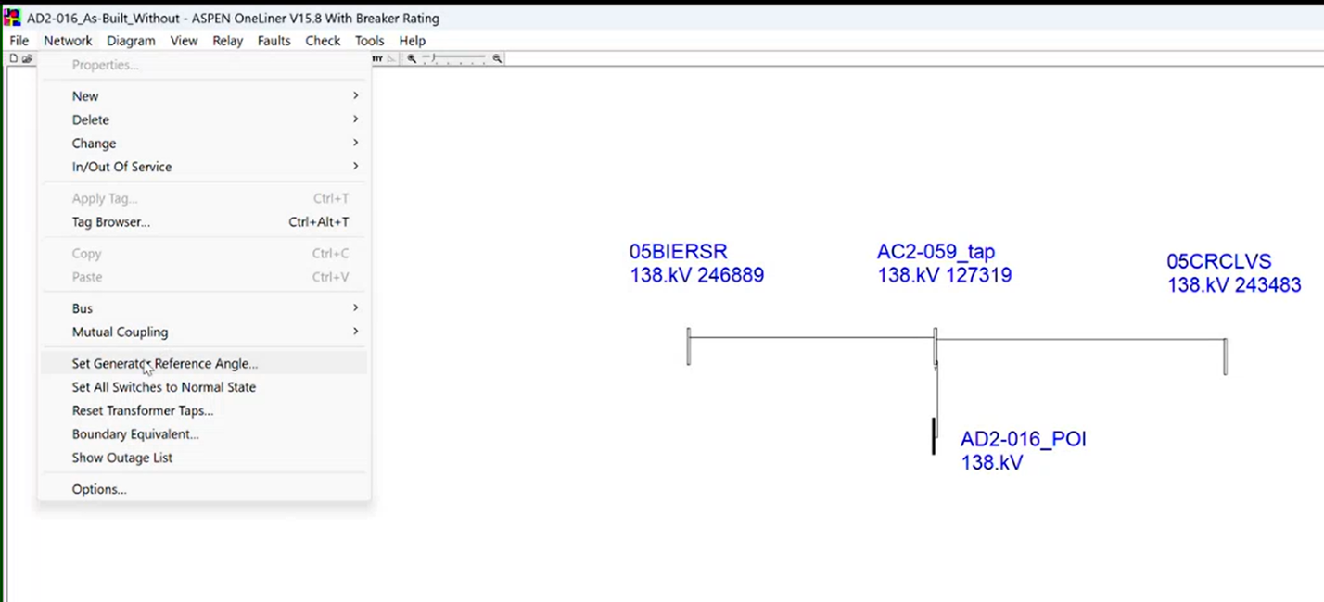

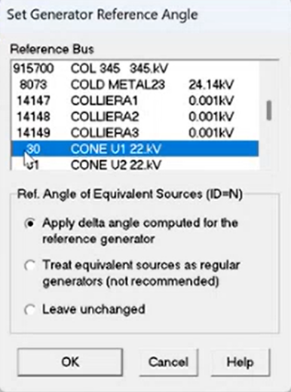

6. Configure Short Circuit Options (OSF File)

6.1 Verify Area Number
- Confirm the Area Number matches the project (from QP/SLD/PJM Serial Service) on the excel calculation sheet as shown below:
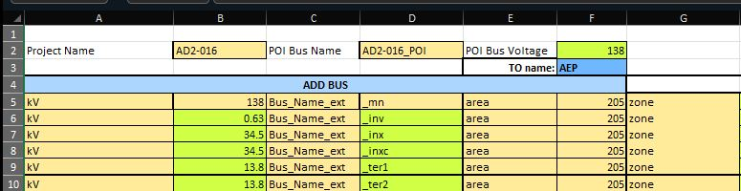
- Update the area number if required on the ASPEN Oneliner “Check Short Circuit Ratings” as shown below:
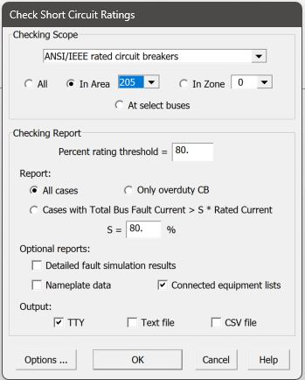

6.2 Load the OSF File
- In OneLiner, go to Options → Load
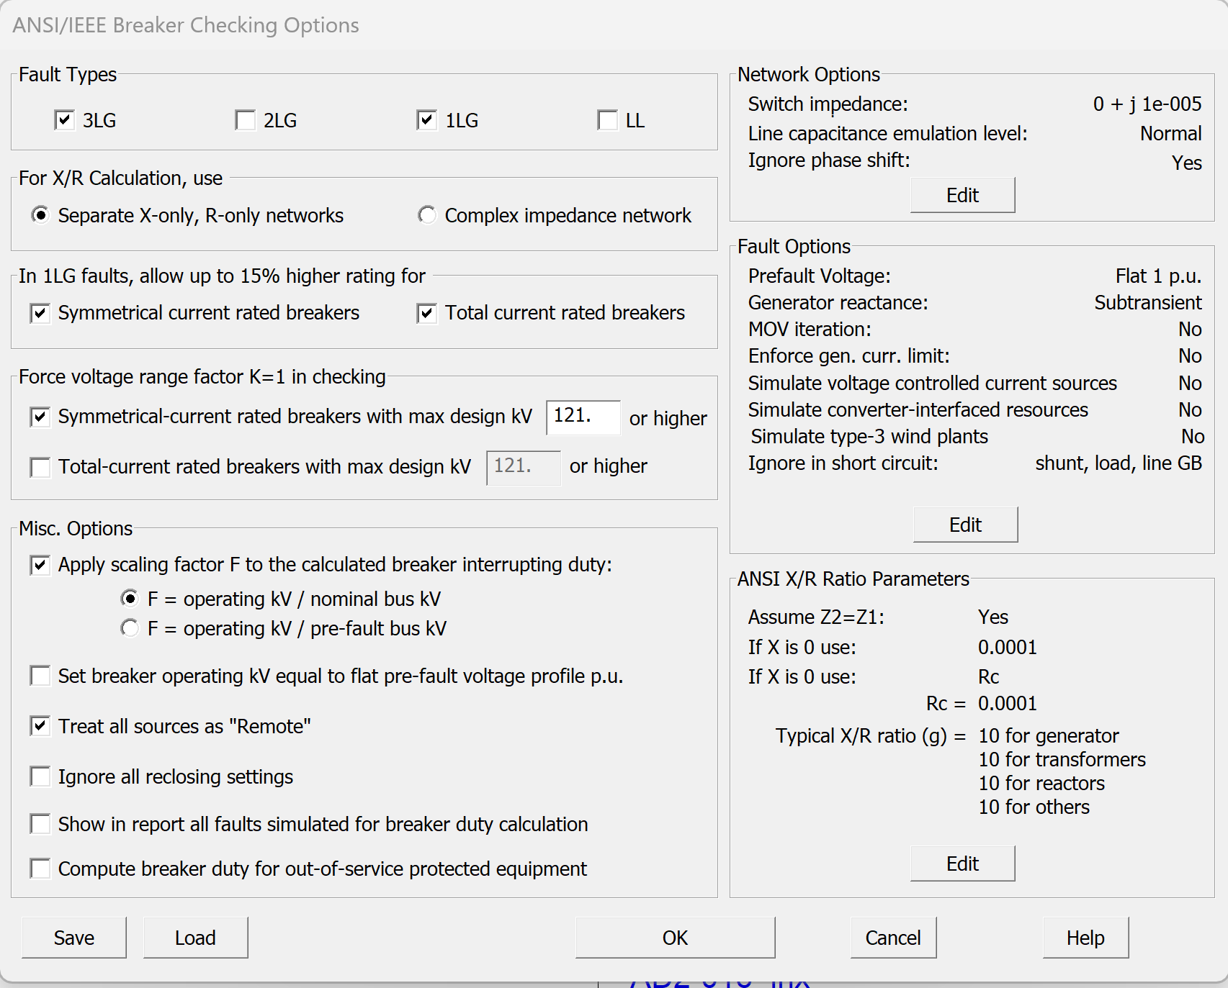
- Select the project‑specific OSF file
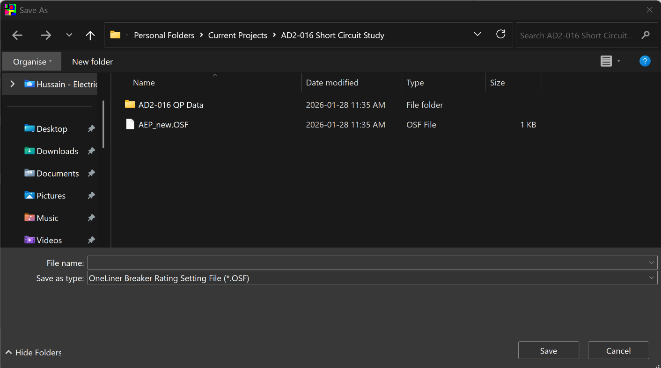
- Click OK to apply settings
- Ensure CSV output is selected
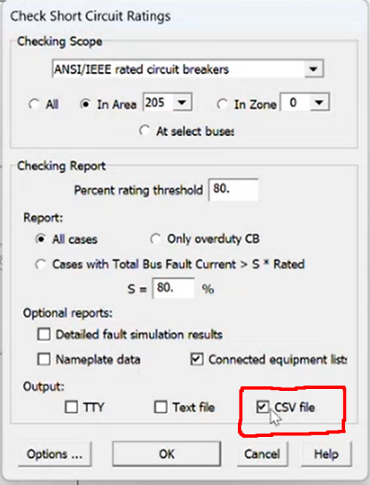
⚠️ Do not reuse OSF files from other projects.

7. Run Short Circuit Cases

7.1 Without‑Project Case (Base Case)
- Confirm project elements are not included
  - Save output as CSV
  - Name file consistently (e.g.ABC-123_As-Built_Without.csv)

7.2 With‑Project Case
- Enable all project elements
- Save output as CSV
  - Name file consistently (e.g.,ABC-123_As-Built_With.csv)

PJM Access required (PJM “DWTH” compare script)

8. Comparison & Deficiency Screening

8.1 With vs. Without Comparison
Compare results to identify: - Significant fault current increases - Equipment exceeding ratings - Changes that trigger PJM/EPE flags

8.2 Load & Rating Checks

9. Clean Working Directory
- Delete *.BAK files (auto‑generated save backups)
- This helps keep outputs clean and review‑friendly

10. Final File Package (Required Deliverables)
A complete short circuit study folder must contain at minimum:
- Change File
- Calculation Spreadsheet
- With‑Case OLR File
- With‑Case CSV Output
- Without‑Case OLR File
- Without‑Case CSV Output
- QP Print-Out
- OSF File
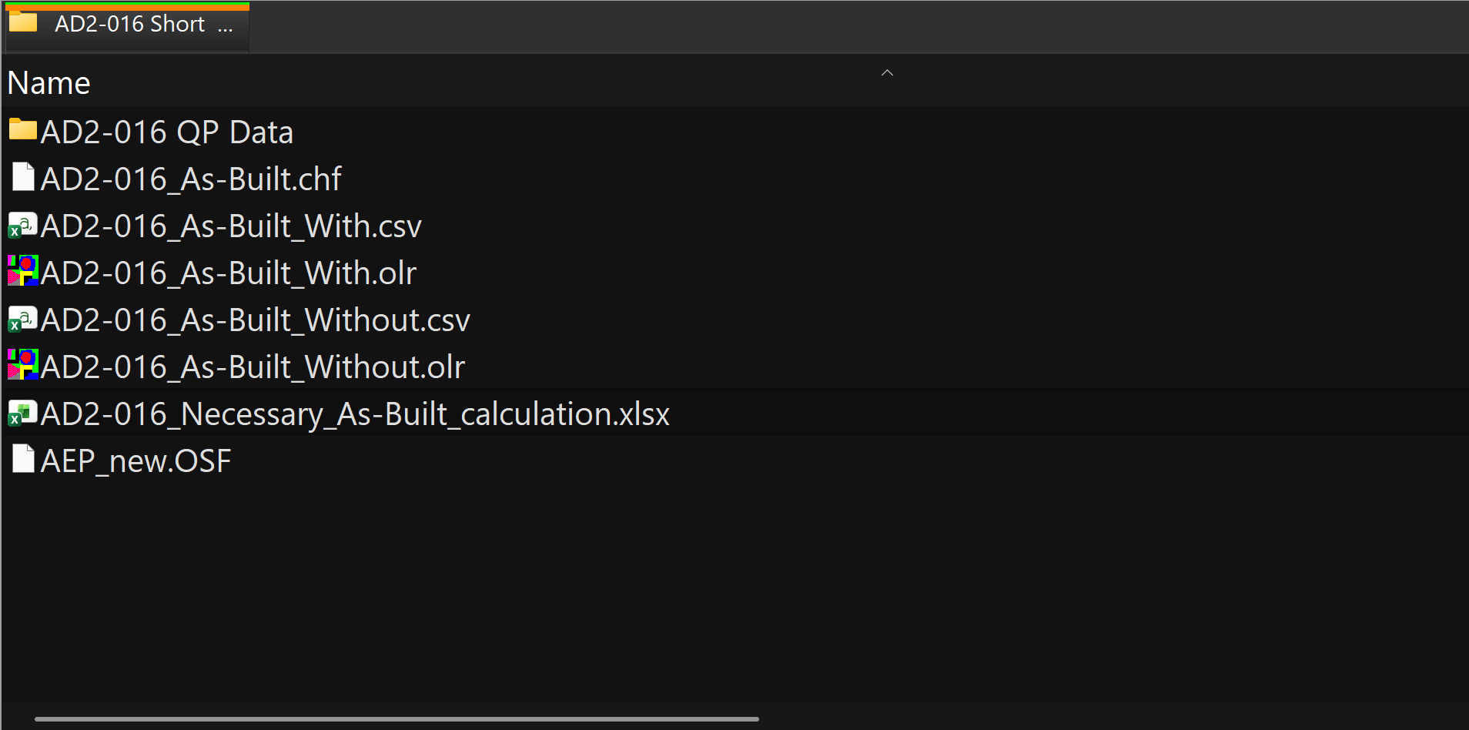

- Running with incorrect area number
- Proceeding with deficient data review

One-Page Quick Checklist (Execution-Only)
Use this after you already understand the process.

Pre-Work
- Obtain OLR file (project-specific)
- Obtain OSF file (project-specific – do NOT reuse)
- Obtain QP Printout or SLD
- Confirm data review status = Approved
- Confirm project status (As-Built vs Necessary)

Case Setup (ASPEN OneLiner)
- Open OLR → File > Save As (project naming)
- Delete *.BAK files (optional cleanup)
- Load OSF → Options > Load OSF
- Verify Area Number → Options > Short Circuit
- Enable CSV Output
- Set Generator Reference Angle

Run Cases
Without Case - ☐ Disable project elements - ☐ Run short circuit - ☐ Save CSV (“_Without”)
With Case - ☐ Enable project elements - ☐ Run short circuit - ☐ Save CSV (“_With”)

Review & Deliverables
- Review fault current changes
- Verify equipment ratings
- Complete calculation spreadsheet
- Confirm final 6 required files present

ASPEN OneLiner Menu Path Callouts

Open / Save Case
- File > Open
- File > Save As

Load OSF File
- Options > Load OSF

Short Circuit Settings
- Options > Short Circuit
  - Area Number
  - Output Format (CSV)
  - Generator Reference Angle

Run Short Circuit
- Run > Short Circuit (or toolbar shortcut)

Output Files
- CSV files auto-generated in project directory

SOP Classification
This document is intended to function as a Standard Operating Procedure (SOP) for: - Short Circuit Studies - ASPEN OneLiner - EPE / PJM-style interconnection projects
Sections align with typical SOP structure: 1. Purpose & Scope 2. Inputs & Preconditions 3. Step-by-Step Procedure 4. Outputs & Deliverables 5. Quality Checks & Best Practices

End of Checklist
This checklist represents a complete, generic workflow for performing short circuit studies in ASPEN OneLiner and can be reused for all future projects.

